**DAILY ONLINE ACTIVITIES SUMMARY**

|  |  |  |  |  |  |  |  |  |
| --- | --- | --- | --- | --- | --- | --- | --- | --- |
| **Date:** | **01-06-2020** | | | | | **Name:** | **Shiza Amreen.J** | |
| **Sem & Sec** | **4th sem B sec** | | | | | **USN:** | **4AL18CS078** | |
| **Online Test Summary** | | | | | | | | |
| **Subject** | | **Complex Analysis, Probability and Statistical Method** | | | | | | |
| **Max. Marks** | | **30** | | **Score** | | | **29** | |
| **Certification Course Summary** | | | | | | | | |
| **Course** | **Python for Machine Learning** | | | | | | | |
| **Certificate Provider** | | | **GreatLearning** | | **Duration** | | | **5 Hours** |
| **Coding Challenges** | | | | | | | | |
| **Problem Statement:**   1. **Define a class Point with two fields x and y each of type double. Also , define a method distance(Point p1, Point p2) to calculate the distance between points p1 and p2 and return the value in double.. Use Math.sqrt( ) to calculate the square root.** 2. [**Given an array arr[] of size N and an integer K. The task is to find the count of subarrays such that each subarray has exactly K distinct elements.**](https://github.com/orgs/alvas-education-foundation/teams/2nd-year/discussions/90) | | | | | | | | |
| **Status: Completed** | | | | | | | | |
| **Uploaded the report in Github** | | | | | **yes** | | | |
| **If yes Repository name** | | | | | **Lockdown_Coding** | | | |
| **Uploaded the report in slack** | | | | | **yes** | | | |

Online Test Details:

Today I had Maths IA-3, I have attended the test and got 29 out of 30.

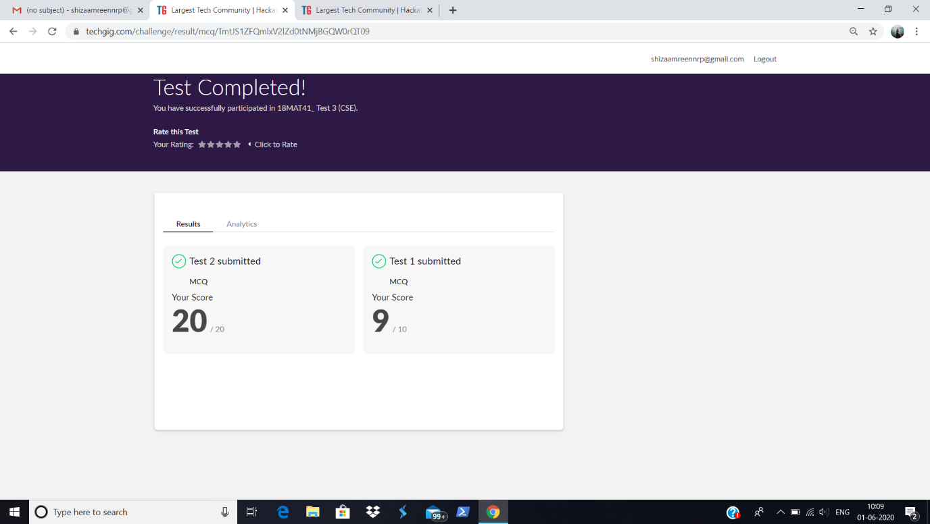

Certification Course Details:

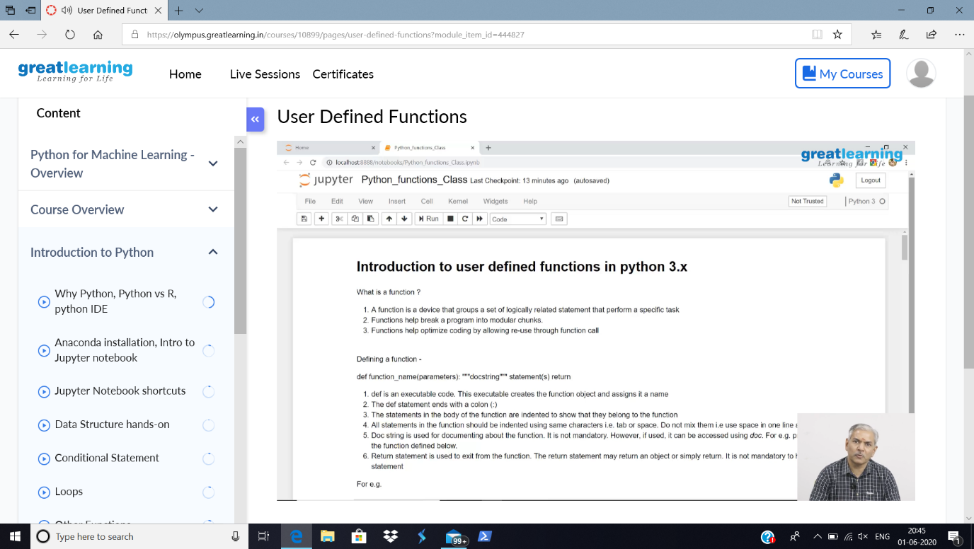

Today in the course Python for Machine Learning, I have learnt about the User Defined Functions in Python 3.x

Coding Challenges Details:

**Problem Statement:**

1. **Define a class Point with two fields x and y each of type double. Also , define a method distance(Point p1, Point p2) to calculate the distance between points p1 and p2 and return the value in double.. Use Math.sqrt( ) to calculate the square root.**
2. [**Given an array arr[] of size N and an integer K. The task is to find the count of subarrays such that each subarray has exactly K distinct elements.**](https://github.com/orgs/alvas-education-foundation/teams/2nd-year/discussions/90)

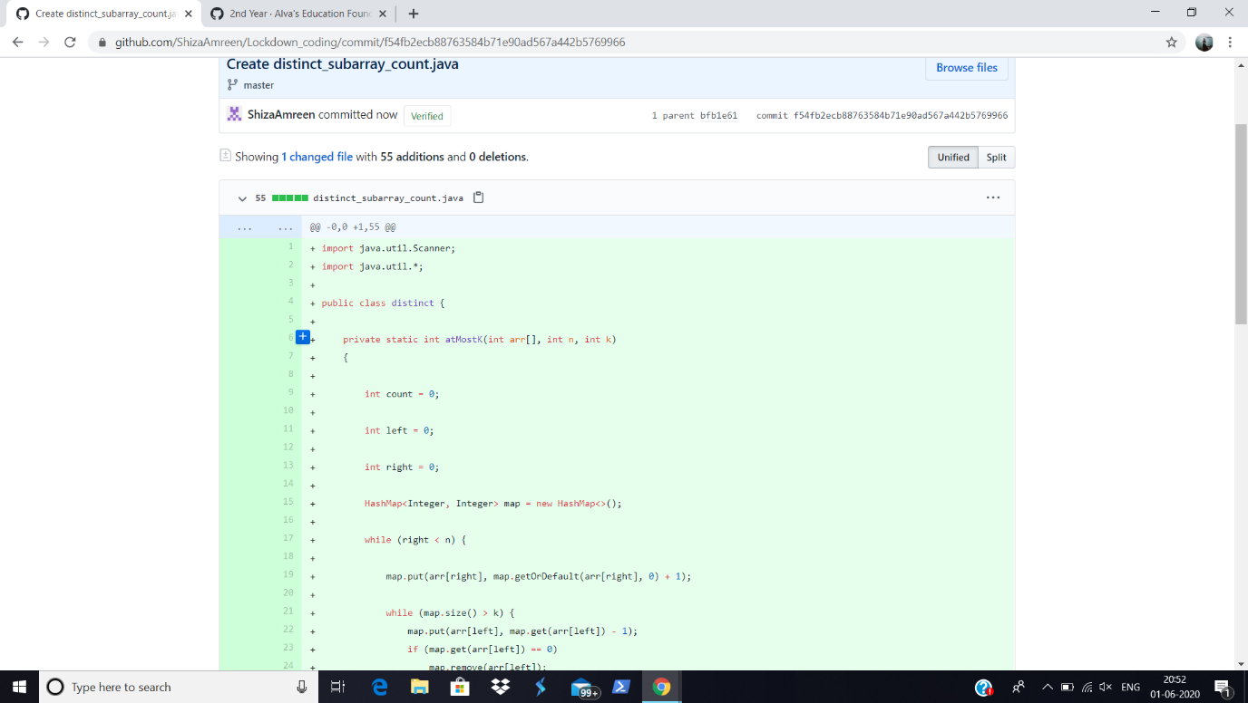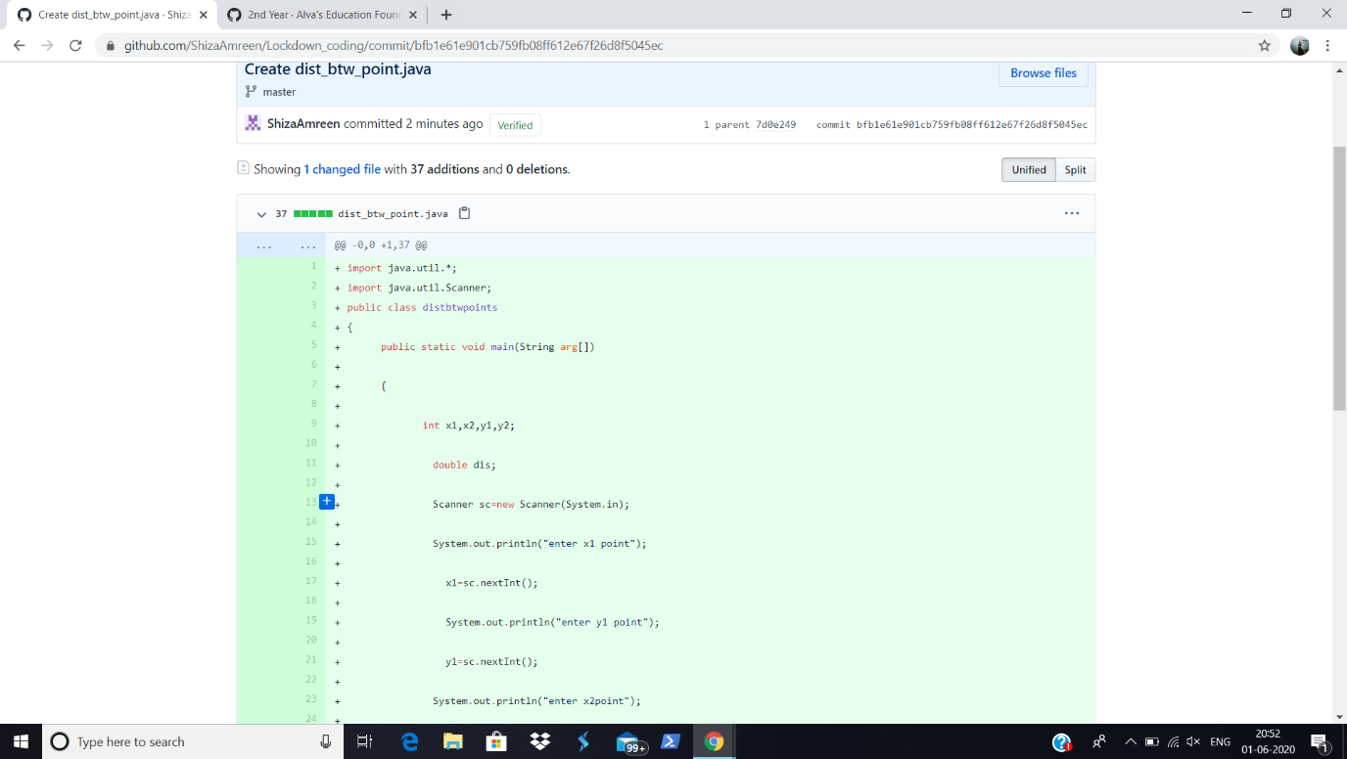

I have written the code for above given problem statements and uploaded it in my github repository, Lockdown_Coding.

<https://github.com/ShizaAmreen/Lockdown_coding/commit/f54fb2ecb88763584b71e90ad567a442b5769966>

<https://github.com/ShizaAmreen/Lockdown_coding/commit/f54fb2ecb88763584b71e90ad567a442b5769966>